The past sections have demonstrated how to find many properties of graphs using calculus. This section will review key properties of graphs that calculus can tell and then show how to sketch a curve by hand.

# Domain

The domain is the set of values of $x$ where the function $f(x)$ is defined (section 1.1). See Figure 1; the brighter blue line means the domain.

The graph should and will only appear in these $x$-values.

Figure

# Intercepts

Intercepts are where the function *intercepts*, or touches, axes (section 1.1). There are two kinds:

|  |  |
| --- | --- |
| $y$-intercept | $x$-intercept |
|  |  |
| This is where the function $f$ intercepts the $y$-axis. | This is where the function $f$ intercepts the $x$-axis. |
| To find the $y$-intercept, evaluate $f(0)$. | To find the $x$-intercept, set $y=f(x)=0$ and solve for $x$. |

**Note**: The book says that you can omit finding the $x$-intercepts for difficult-to-solve problems.

# Symmetry

Symmetry is the way that a function repeats (section 1.1).

A function $f(x)$ can be classified as zero or more of these kinds of symmetric functions:

|  |  |  |
| --- | --- | --- |
| Even function | Odd function | Periodic function |
|  |  |  |
| $$f\left(x\right)=f\left(-x\right)$$ | $$f\left(-x\right)=-f\left(x\right)$$ | $$f(x)=f(x+p)$$ |
| The function is symmetric around the $y$-axis. | The function is symmetric when rotated $180°$. | The function repeats at every **period $p$** . ( $p$ is smallest possible) |

To find which symmetries a function has, check it visually against this table or see if it fits any of the general equations in the table (section 1.1).

# Asymptotes

Asymptotes are where either the function or its $x$-value *approaches infinity* and a constant value (section 1.3). There are two kinds:

|  |  |
| --- | --- |
| Horizontal asymptote | Vertical asymptote |
|  |  |
| At these, $x$ approaches positive or negative infinity and $y$ approaches a constant. | At these, $x$ approaches a constant value from the left or the right and $y$ approaches positive or negative infinity. |

To find if or where a function has (an) asymptote(s):

* See where it looks like the function’s approaching infinity (section 1.3).
* Make a limit where $x$ approaches the number where it seems there’s an asymptote.
* Evaluate the limit to see if and where exactly the asymptote exists.

# Intervals of Increase or Decrease

Intervals of increase or decrease are where functions continuously *increase* or *decrease* (section 1.1).

|  |  |
| --- | --- |
| Interval of increase | Interval of decrease |
|  |  |
| In these, the function is continuously increasing. | In these, the function is continuously decreasing. |

To find intervals of increase or decrease, use the I/D Test (section 4.3).

# Local Maximum and Minimum Values

Local maximum and minimum values are where the function is at its *greatest* or *least* values respectively in a certain interval (section 4.1).

|  |  |
| --- | --- |
| Local maximum | Local minimum |
|  |  |
| At these, the function reaches its maximum (highest, most positive) value in an interval. | At these, the function reaches its minimum (least, most negative) value in an interval. |

To find the local maximum and minimum values, you can use any of these tests:

* First Derivative Test (section 4.3)
* Second Derivative Test (section 4.3)

# Concavity and Points of Inflection

Concavity is, in an interval, the direction that the function “opens”, the direction it is constantly increasing towards (section 4.3).

In the strictest sense, the concavity of a function is upward in an interval if the function’s second derivative is always positive in that interval; vice versa for downward and negative.

|  |  |
| --- | --- |
| Concave Upward | Concave Downward |
|  |  |
| The function “opens” upward, over itself. | The function “opens” downward, under itself. |

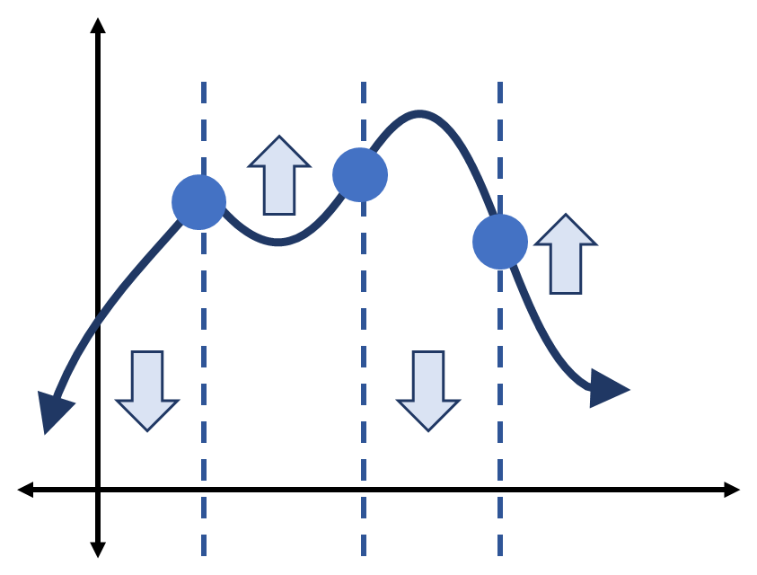To find the concavity of a function, use the concavity test (section 4.3).

Inflection points are where the concavity changes (section 4.3). See Figure 2; the inflection poitns are blue circles.

To find the inflection points, prove where $f''$ changes from positive to negative or vice versa. (This is true because $f''$ is used to find if an interval is concave downward or upward.)

Figure

# Sketch the Curve

The book[1] recommends this procedure for sketching the curve by hand:

1. Sketch the asymptotes as dashed lines.
2. Plot the intercepts.
3. Plot maximum and minimum points.
4. Plot inflection points.
5. Draw the curve with its intervals of increase and decrease and concavity; approach the asymptotes.
6. For additional accuracy at any point, compute the derivative at it to find the curve’s slope there.

If you use a graphing calculator, instead *start* with the graph, then adjust the viewing domain and range, possibly plotting the same curve with different settings to extract its key features. Use calculus to discern where those key features will be.

# How Would You Answer?

* What is/are: domain? intercepts? symmetry? asymptotes? intervals of increase or decrease? local maximum and minimum values? concavity and points of inflection?
* How are points of inflection related to maximum and minimum values? Where are points of inflection also extrema? Why are most extrema also points of inflection? Why is this not always the case?
* How can the symmetry of a function make it easier to calculate other properties of the function?

1. Essential Calculus – Early Transcendentals (Second Edition) by James Stewart. Page 226.